CMS Code of Ethics
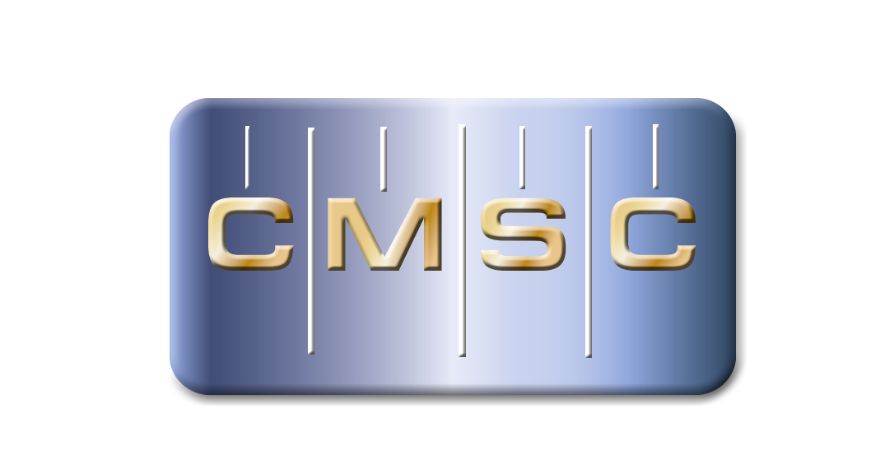

Coordinate Metrology Systems Conference
30210 SE 79th St., Suite 100 | Issaquah, WA 98027 | (425) 802-5720 | www.cmsc.org
7/16/2012

Coordinate Metrology Society - Code of Ethics
Honesty, justice, and courtesy form a moral philosophy which, associated with mutual interest among people, should be the principles on which ethics are founded.
Each person who is engaged in the use, development, and improvement of coordinate metrology should accept those principles as a set of dynamic guides for conduct and a way of life rather than merely for passive observance. It is an inherent obligation to apply oneself to one's profession with all diligence and in so doing to be guided by this Code of Ethics.
Accordingly, certified members of the Coordinate Metrology Society (CMS) shall have full regard for achieving excellence in their practice and the essentiality of maintaining the highest standards of ethical conduct in responsibilities and work for an employer, all clients, colleagues and associates, and society at large, and shall:
- Be guided in all professional activities by the highest standards and be a faithful trustee or agent in all matters for each client or employer.
- At all times function in such a manner as will bring credibility and respect to coordinate metrology activities.
- Not compete unfairly with anyone who is engaged in coordinate metrology by:
  - Advertising in a self-laudatory manner;
  - Exploiting one's own or another's employment position for personal financial gain.
  - Criticizing other persons working in or having an interest in coordinate metrology in public or private.
  - Exercising undue influence or pressure, or soliciting favors through offering monetary inducements.
- Work to strengthen coordinate metrology applications by:
  - Improving one’s personal skills and knowledge;
  - Exchanging information and experience with other persons interested in and using coordinate metrology, with other professions, and with students and the public;
  - Providing opportunities for technical and professional development and advancement of persons working under his or her supervision;
  - Promoting the principle of appropriate compensation for work done by persons in their employ.
- Undertaking only such assignments in the use of coordinate metrology for which one is qualified by education, training, and experience, and employing or advising the use of experts and specialists when and whenever clients' or employers' interests will be best served thereby.
- Giving appropriate credit to other persons and/or firms for their technical and professional contributions.
- Recognizing the proprietary, privacy, legal, and ethical interests and rights of others. This not only refers to the adoption of these principles in the general conduct of business and professional activities, but also as they relate specifically to the appropriate and honest application of coordinate metrology, and related technologies.
- Subscribers to this code shall not condone, promote, advocate, or tolerate any organization's or individual's use of these technologies in a manner that knowingly contributes to:
  - Deception through data alteration;
  - Circumvention of the law;
  - Transgression of reasonable and legitimate expectation of privacy.

_________________________ ____________
Printed name Date
_________________________
Signature

